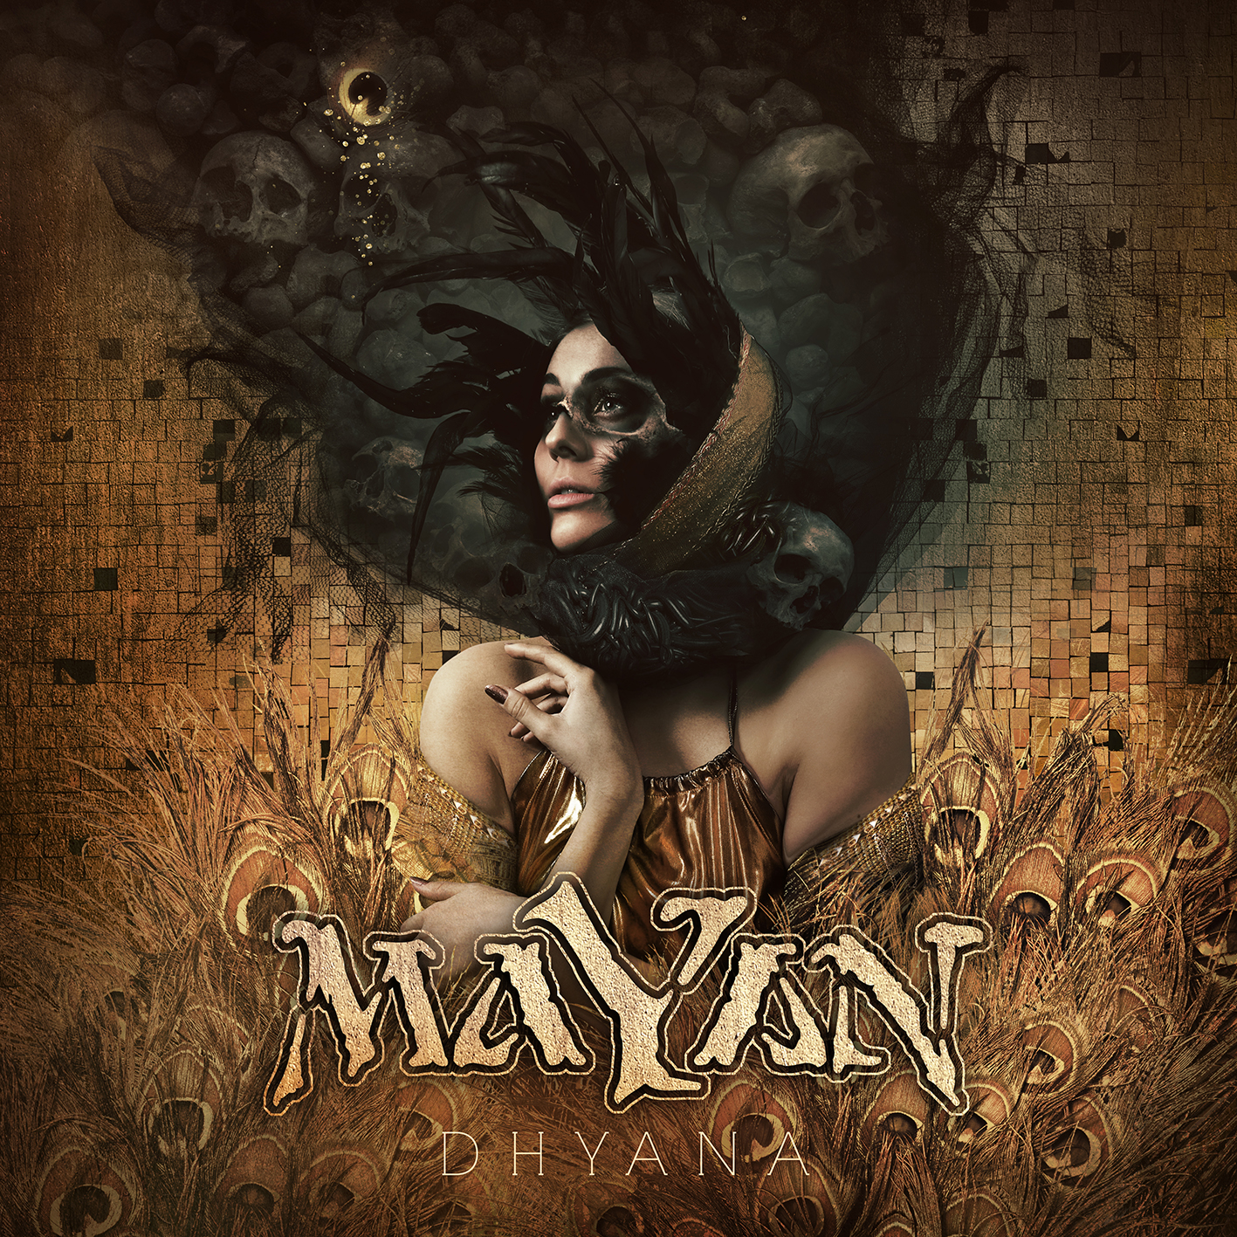

MAYAN
»Dhyana«

out September 21st, 2018

Live line-up: | MAYAN online:
Mark Jansen, George Oosthoek | grunts  Adam Denlinger / Henning Basse | clean male vocals  Laura Macrì, Marcela Bovio | clean female vocals  Jack Driessen | keyboards  Frank Schiphorst, Merel Bechtold, Arjan Rijnen, Jord Otto | guitars  Roel Käller | Bass  Ariën van Weesenbeek | drums | www.mayanofficial.com  www.facebook.com/mayanofficial  www.nuclearblast.de/mayan
MaYaN was conceived in early 2010 by versatile musician and EPICA mastermind Mark Jansen and old friend, ex-AFTER FOREVER keyboardist Jack Driessen with the aim to write an album in the style they always really wanted. Mark asked guitarist Frank Schiphorst (SYMMETRY, CHRISTMAS METAL SYMPHONY) to join the fold. Frank has undoubtedly brought a broad range of experience and skills aboard, and when put together with Mark and Jack, an undeniable chemistry takes place producing songs in no time.

Evolving from a project to a real band, MaYaN needed the perfect musicians to help achieve this, and as a logical result EPICA drummer Ariën van Weesenbeek and guitarist Isaac Delahaye joined. Soon guest vocalists Henning Basse (currently FIREWIND), Laura Macrì, Simone Simons (EPICA) and Floor Jansen (currently NIGHTWISH) also became a part of the adventure. Not long later, they were followed by bassist Rob van der Loo (ex-DELAIN).

With their first release »Quarterpast« (2011) coming out through Nuclear Blast, MaYaN received instant recognition in the media, substantiated by excellent reviews, in-depth interviews with countless provoking questions about the band‘s point of view on top of rave reviews from fans throughout the world.
After many very successful tours throughout parts of Europe, Central and South America plus playing renowned festivals like ProgPower USA, Graspop Open Air, Heaven & Hell (Mx), Zwarte Cross and PPM Fest for thousands of fans, the band instantly put themselves on the map. Hundreds of thousands of views and confronting discussions from all over the world in regards to their video ‘War on Terror’ prove that MaYaN aim to set the world to think about and hopefully act upon the current state of things.

Laura and Henning joined the MaYaN tribe as permanent members in 2013. That same year, Isaac was replaced by the talented female guitarist Merel Bechtold (currently DELAIN).

In 2014, MaYaN released their second full length album »Antagonise« through Nuclear Blast and introduced two great guest musicians: Vocalist Marcela Bovio (STREAM OF PASSION), giving extra depth by adding choral layers and vocal lines, and Greek violin virtuoso Dimitris Katsoulis. The »Antagonise« concept is about the current state of the world in which surveillance is more present than ever before. Our privacy is being eroded step by step. Some people say "We have nothing to hide so I don't care", but we all have our secrets. Under the flag of the 'war against terrorism' governments - and above all the big corporations - all over the world have found a handy way to control people and get their way without much or any resistance. They spread fear in order to gain more power, more money and to stay in total control. It's increasingly hard to find good documentaries about this subject on TV as little of the media is truly independent. But if you really search for the truth, you'll get the truth. Songs like 'Faceless Spies' and 'Paladins of Deceit' (National Security Extremism part 1 & 2) are perfect examples of these subjects being presented on »Antagonise«. »Antagonise« was the first MaYaN album to enter the official Dutch and Belgian album charts. It received rave reviews and was recognised as album of the month in leading Dutch metal magazine Aardschok and album of the week in Revolver Magazine.
In the meantime Rob joined Epica, after which he was replaced by the talented 6-string fretless bass player Roel Käller (SKULLSUIT).

Because MaYaN has always had a profound love for epic movie scores, the next logical step was to record a new album with a live symphonic orchestra. To make this happen, an IndieGoGo crowdfunding campaign was started in early 2018, with the aim of facilitating MaYaN recording their 3rd album »Dhyana« with a real orchestra. The »Dhyana« concept reflects on conceptual themes such as remaining aware of our thoughts, removing egoist tendencies, and finding out who we truly are. »Dhyana« is the moment when the individual mind is absorbed by the heart and merges with the universal mind. The crowdfunding campaign also aimed to facilitate a new and exclusive EP called »Undercurrent«. Receiving tremendous support from fans, the campaign ended successfully, raising more than €40,000 which covered all costs involved.

MaYaN chose The City of Prague Philharmonic Orchestra to partner with in recording »Dhyana«. This world-renowned symphonic orchestra was founded over 60 years ago and is one of the most respected and recorded orchestras globally. They are known for their work in cinematic features such as the Star Wars saga, Hannibal (2001), and Arrival (2016). They are also known for recording the orchestral parts of DIMMU BORGIR’s album »Death Cult Armageddon«. The orchestra recordings took place in June 2018, and both MaYaN’s 3rd full-length release ‘Dhyana’ and EP ‘Undercurrent’ will see the light of day in September 2018!

Having mostly touring musicians in the band, MaYaN needs to rotate sometimes with musicians to be able to continue doing live shows and deliver the highest quality on stage. So another new member was added to strengthen the Tribe even more: renowned grunter George Oosthoek (Orphanage)! Next to that, backup guitarists for Merel have been found in Arjan Rijnen (REVAMP) and Jord Otto (VUUR, MY PROPANE), who both have proven their great presence at several live shows with MaYaN. Los Angeles based vocalist Adam Denlinger takes care of all clean male vocals, since Henning stepped back from being a band member due to obligations to his band FIREWIND. Henning is now hired as a 'special guest' every now and then. Adam made his impressive live debut with MaYaN in a full Metal Dome at Graspop Metal Meeting 2017. Marcela already got to be a part of the family with her joining MaYaN on most live shows through the last years, so she joined as a fully contributing member as well. MaYaN nowadays is seen as a multi functional metal dream team featuring the best possible musicians, not to be held back!

